Wild Animal Management Assignment
Name of Author:
Institution:
Date:

Observation of Four Animals Native to Ireland
- The Red Squirrel
Figure 1: The Irish Red Squirrel
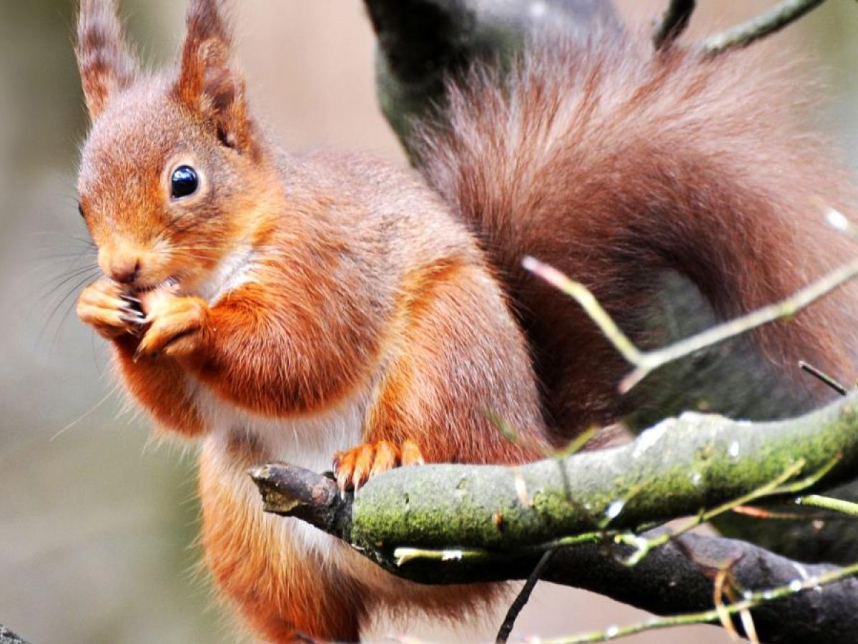
Description & Appearance: Belonging to the rodent family, the red squirrel is reddish brown in color as its name suggests. It has long ear tuffs and a distinctive bushy tail. Both males and females are just about the same size, growing up to 23cm long with elongated tails between 15cm and 20cm, just as long as a hand of a human adult. When kits, the young weigh only about 10 to 15g but an adult squirrel weighs between 250g and 340g.
Behavior in Natural Habitat: The red squirrels are more active in mornings and late afternoons where they forage through the bushes and woodlands to feed. However, during daytime when the sun’s scorching heat is intense, they rest in their nests to avoid the heat. It is important to emphasize that red squirrels are largely solitary and even hesitate sharing food with others. During breeding, two squirrels may hang out together but largely they are solitary. The red squirrels are competent tree climbers and often they come down the tree trunks headfirst. On the ground too, they are agile and always fast movers.
Courtship & Reproduction: During the mating season such as in summer, a female attracts males by her odor indicating the need to mate. Generally, the male red squirrels chase the female through the bushes and tree canopies until the dominating males eventually wins over to mating. The chase often lasts up to an hour but no prior courtship is done. The gestation period is usually 40 days with the young being born bald, deaf and blind. After 10 weeks of care, the young ones are independent on their own. Adult red squirrels can live up to six years or seven years of age.
Food and Diet: Mainly the Irish red squirrels live on tree (pine) seeds, fruits, fungi, buds. Also, nuts, acorns, insects and berries are preferred food choices. These animals survive by hiding food in certain spots to consume later. These sports are usually hollow tree trunks or well hidden holes.
Relevant Environmental Issues: Categorized as being Near Threatened, increased deforestation is wiping out their habitats. The pressure and disruption from such human activities affects the consistency of their breeding. Currently their populations are decreasing thus the need to protect their habitats.
Evidence of Observation: A spotting of untidy nests up in the trees signify the presence of red squirrels because they are arboreal animals (live on trees). Also, scratch marks on the bark of tree and half-chewed like apple cores at the bottom of trees signify their presence. In a day an adult squirrel can eat up to a quarter of a pound of food in weight.
Account of Observation: One squirrel was observed both closely by a naked eye and by the aid of a binoculars on 14th November 2020 at 5.15pm at Connemara National park. This method of observation was quite effective to determine behaviors in the natural heritage but time constraints could not allow full observations such as over several days and weeks. Additional information was provided by the national heritage website.

- The Red Deer
Figure 2: Red Deer native to Ireland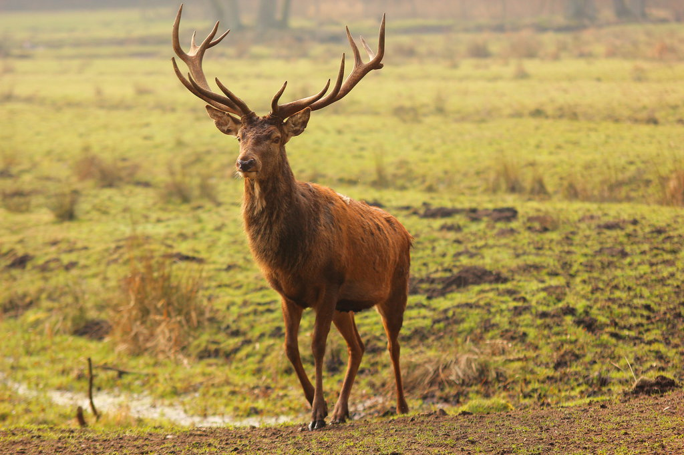
Description & Appearance: These large mammals appear with a reddish brown or a rusty red coasting especially during the summers but tend to appear brown or grey in winters. They are short tailed creatures, with pointed ears and a pale rump patch. They also have a fairly large with well-spaced eyes which are brown in color. Males have a distinctive thick shaggy male on their necks. Males (stags) are more muscular compared to females (hinds) which have a smaller stature. Also, males are distinctive due to the antlers on their head shaped like a curved heart. Typically, a deer can be up to 250cm long and weigh between 160kg and 240. Newborn fawns only weigh up to 8 pounds.
Behavior in Natural Habitat: The Irish red deer prefers woodlands and open grasslands as their habitat. Deciduous forests offer a good tree cover for them with occasional habituating in mountainous regions. They are active animals all years round and mostly prefer to fee in dawn and dusk hours.
Courtship & Reproduction: The red deer live within herds. At the beginning of fall, males enter into the mating period (rut) where they become most active. They emit guttural, deep-voiced roar as a warning to other males to keep off their territory. Aggressiveness during this period include marking vegetation with their scents and digging shallow trenches in which they urinate. Nearby trees may also be frayed and fighting occur in form of locking their antlers. If a male loses such a class, they are dismissed as weaker while the dominant males engages in mating. Mating to the hinds could continuous in that those not pregnant get into mating three weeks later and so on until they acquire pregnancy. Usually hinds gestate for about 240 days to 262 days at the end of which newborn calves are born weighing about 15kgs. These calves wean in just about two weeks where they are strong enough to join the herd. While all the calves are born spotted, they lose their spots as they grow up.
Food and Diet: The red deer are herbivores who fed on grass, herbs, acorns, fruits, tree shoots and low lying shrubs such as heathers. The red deer can also strip of barks from younger trees and feed on the sap. They normally feed during early mornings and late evenings, as they flock in herds. A specific herd is usually led by a dominating male or female herds guided by a mature adult hind. If grass grow scarce, the herds can move fairly long distances in search of food. The mature males often live solitary or in small groups, but females are always part of herds.
Relevant Environmental Issues: Due to their intense feeding and fraying trees in mating seasons, red deer can cause substantial harm to forests. Secondly, red deer, especially, are targets for prey animals such as foxes, wild dogs and wild boars among other predators. The shrinking of their habitats pose a danger to their populations and there is a need for dedicated conservation efforts to ensure adequate habitats.
Evidence of Observation: A herd of red deer were observed by the use of a binoculars at a distant. The time was on 4.35pm on 12th November 2020 at the Connemara National park. The method was effective to see general behaviors including ritualistic mating mannerism. Time limitation was however a major setback. The national heritage website has adequate information on this mammal.
Account of Observation: Evidence of the red deer include black-brown dropping about 2cm in length. Frayed shrubs and bushes as well as shallow trenches indicate male’s aggressiveness during their mating season.

- Rabbit
Figure 3: A Rabbit Native to Ireland
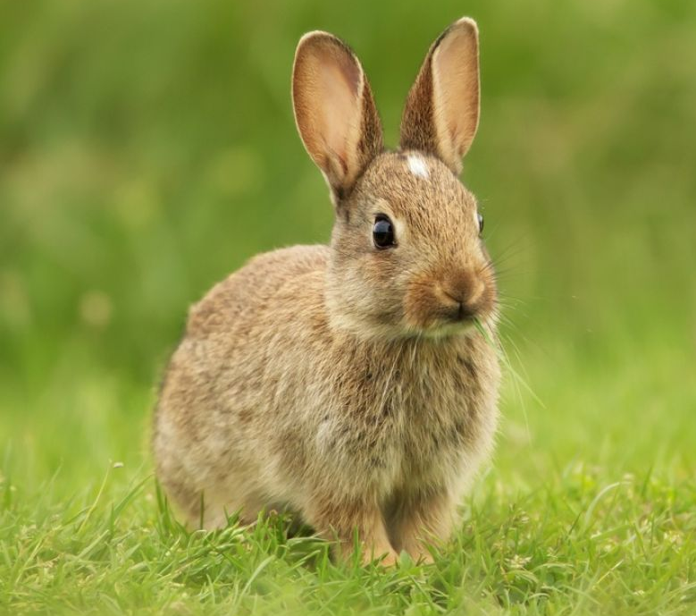
Description & Appearance: The rabbits which are native to Ireland are small Leporid with diverse fur discolorations. Some rabbits can have a brown fur, sandy furs or black with a distinctive greyish tint on underbelly. They are small animals with males weighing about 2kg in comparison to females at 1.5 kg. The adult rabbit is about 50cm long with a short fluffy tail about 10cm in length. Besides, they have larger hind legs adapted to hopping from one point to another. Their eyes are large permitting a 360 degree scanning of the surroundings to quickly evade danger when a predator is sighted. Their little sensitive noses are adapted to smelling with small mouths for chewing. While the Irish rabbits are non-vocal, in event of threat, they can emit loud squeaks.

Behavior in Natural Habitat: The rabbits usually reside in open grasslands, meadows, deciduous woodlands, thick bushes and even in underground holes. Near water bodies like seas, they reside in the soft sand dunes. The rabbits usually live around each other in large groups. The rabbits move around by hopping and can accelerate to fast galloping. They have a preference in habitants that offer instant cover in case of danger such as hedgerows, overgrown grasses, rocky areas or where they are burrows because they are natural diggers. Their behavior is instinctive and rush to hiding at any onset of danger or disruption. However, when relaxed, they flop on the side to show contentment and relaxation.
Courtship & Reproduction: The breeding for this rabbits is usually through the year. Males in the group could mate the females for a number of days. Once pregnant, a female can give birth to between three and seven litters annually. The female carried the pregnancy for about 30 days which would be born blind and furless. It would only weigh about 50g and would open eyes on the tenth day. The litters are kept in well hidden places such as burrows where the female tends to them by lactating. About 18 days after they are born, the litters wean and seek sourcing with food along with the female. Within three months, they reach sexual maturity and they would grow to up to 10years but average mortality is about 6 years.
Food and Diet: Armed with sharp teeth, rabbits are herbivores and they grind through food continually till it is soft for swallowing. They consume a wide range of vegetation such as leaves and herbage), tree seedlings and even saplings. The ideal time for grazing is during dawn and dusk while they remain largely hidden or docile during the day.
Relevant Environmental Issues: The rabbits love natural settings and any human disruptions presents stress that affect their wellness and consistency. The human’s hunting of rabbits for food also accounts for deaths. Disruptions and attacks by predators such as minks, stoats, foxes and some predatory birds have decimated their populations. Viral illnesses such as the viral hemorrhagic disease spread fast since the rabbits live in social groups. Use of machinery, and some agrochemicals also pose significant danger to breeding and health of the rabbits. Conservation measures are needed to ensure their numbers are protected.
Evidence of Observation: Rabbits leave distinctive marks as they move around with their hind legs leaving a Y-like trail. Burrows on the ground also signify the presence of the rabbits. They can also be identified by clustered droppings that are greenish or yellow-brown in color and marred by grass.
Account of Observation: A group of five rabbits (2 male and 3 female) were observed on 11th November 2020 at a sanctuary within Connemara National park at 8.15 am. No equipment was used and the method was effective to observe their behaviors in a natural habitat. The challenges was that they kept galloping too their hiding areas during any disturbance. I relied on the national heritage website to compile additional information on this animal.

- Hedgehog
Figure 4: The Irish Hedgehog
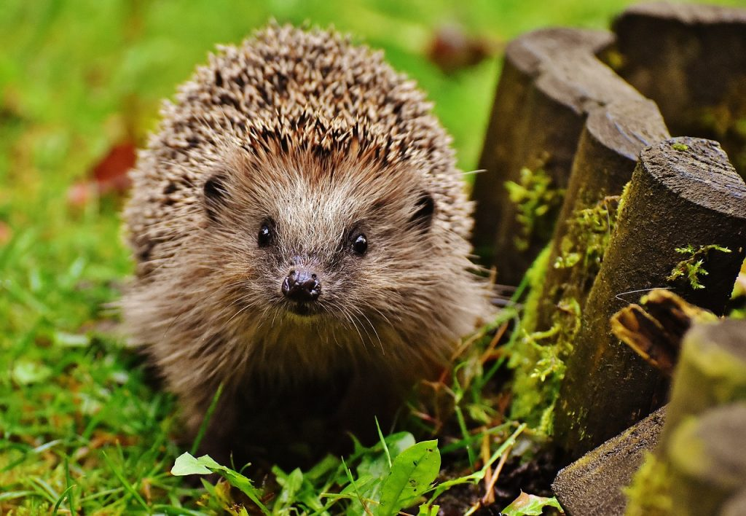
Description & Appearance: The Irish hedgehog is a small mammal that has a greyish brown color and its body has numerous dark-brown spines. The spines as a defense from the predators that include among others owls, foxes, wolves and mongoose. The spines are just hardened hairs that would reach up to 2cm long. They hedgehogs have a small tail about 3cm in lengths and adults have a 27cm body length. These mammals have no distinctive neck, have a long snout and rump shaped like a barrel. Their legs are short with five clawed toes on their hind legs. They also have well developed ears for hearing but have small eyes with very poor sight. Finally, they emit squeals like pigs although in less aggressive ways. Finally, the males are bigger in size compared to the females.
Behavior in Natural Habitat: Open grasslands, scrub and deciduous woodlands make good homes for the hedgehogs. As adaptive animals, they also reside in meadows, and hedgerows among other overgrown areas. They live in grass nests or nests formed from other vegetation such as leaves and branches. A nest often holds only one hedgehog at a time since they are mainly solitary animals. Clashes between males are common when one invaded the territory of the other, and even females fight a lot too. Regarding their behaviors, they are mainly nocturnal but rely more on hearing for their eyesight is quite poor. At any slightest hint of danger, they roll into a ball of needles, scaring away any predator.
Courtship & Reproduction: The breeding of hedgehogs is not aggressive and a female may have only one litter over the course of a year. Most births are mid-year around June and July. The mating is about scent attraction and noisy interaction between a male and female. Gestation is about five weeks after which the litters are born blind, and without hair. After eleven days, the young ones (piglets), are able to roll into balls as a mechanism for self-protection. Disturbances in the nest can cause the female to evade leaving behind the litters or even eat up a litter and coil into a spiked ball. After four weeks, the suckling stops and they actively seek own food. The spikes grow over time and by the ninth month, the piglets have reached a sexual maturity age. In wild Ireland, the hedgehog’s lifespan is high as 10 years but averagely they live up to three years.
Food and Diet: hedgehogs’ diet include insects like beetles as well as invertebrates like snails and millipedes. They are also opportunistic mammals preying on eggs, frogs, decaying carrion and even fallen fruits.
Relevant Environmental Issues: Hedgehogs travel fast and can make temporary nests on farms and bushes near areas settled by humans. They help farmers as they dine on plant pests such as slugs and snails. However, unkind human behavior leads to killing them off. Also, increasing farming also reduces their habitat areas in addition to using agrochemicals. The increased fragmentation and deforestation is putting significant stress on the hedgehogs. The numbers of these mammals are dwindling and is a call for concern for more suited conservation efforts including protection from human-related deaths.
Evidence of Observation: Their droppings are sausage shaped, black in color, and shiny, often containing fragments from seeds and insect parts. Large peculiar nests observed also point to presence of the hedgehogs.
Account of Observation: A male adult hedgehog was closely observed on the evening of 16th November 2020 in Connemara National park from 17.40pm. A binoculars was used for the observation and the method was effective to observe behavior. For instance, the rolling into a ball was fascinating and I was able to relate to the theoretical study on this protective behavior. Then, the national heritage website was handy to provide more information about the Irish hedgehog.

